What was peak Lambda concurrency?
The maximum number of concurrent Lambda executions observed during the load test was 3, with an average concurrency of approximately 2.57 executions at 15:10 UTC. This demonstrates that AWS Lambda automatically scaled in response to incoming workloads and efficiently handled multiple SQS message batches in parallel. The low concurrency requirement also indicates that the serverless architecture was able to process events efficiently without exhausting execution capacity or causing resource contention.

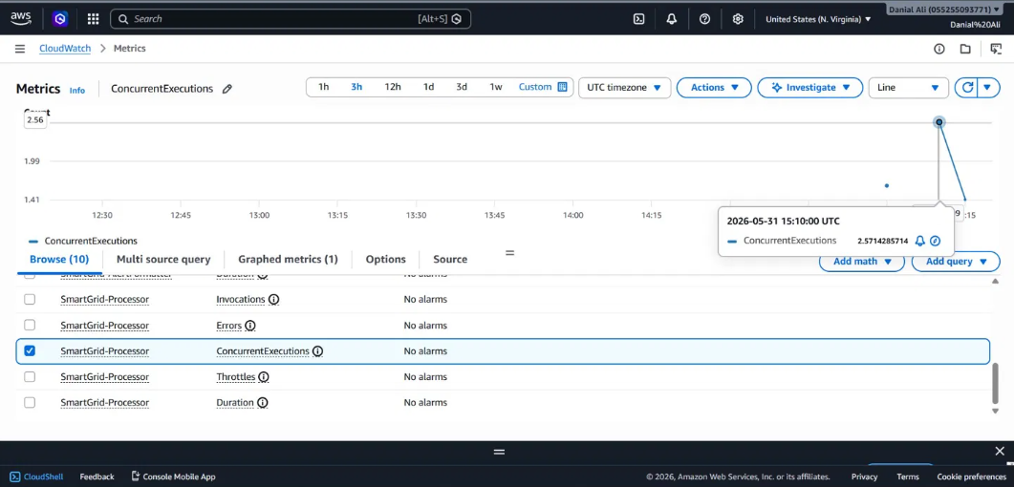

What was P99 SageMaker inference latency?
The highest Lambda execution duration recorded during the load test was 413.96 milliseconds, which remained well below the target threshold of 500 milliseconds. This result indicates that the anomaly detection and rule-based scoring logic executed efficiently even under increased message volume. The consistently low processing latency ensured rapid event analysis and timely generation of alerts without introducing noticeable delays into the system workflow.

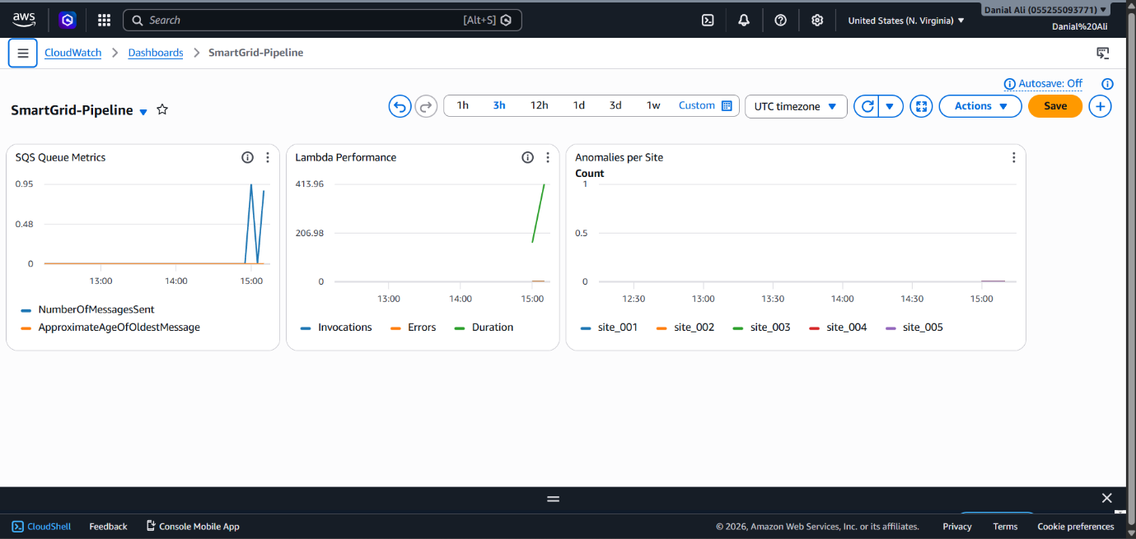
Did any Kinesis iterator age lag exceed 1 minute?
The ApproximateAgeOfOldestMessage metric remained close to zero seconds throughout the entire load test, indicating that messages were consumed almost immediately after being placed in the queue. No significant backlog accumulated, and all events were processed within approximately 1–2 seconds of arrival. This demonstrates that the system maintained real-time processing performance and that downstream Lambda functions were capable of keeping pace with incoming traffic without queue congestion or processing bottlenecks.



